PROJECT REPORT
Project Name: TransLingua – AI-Powered Multi-Language Translator
Development Team Id: LTVIP2026TMIDS84504
GitHub Repository: TransLingua-AI-Powered-Multi-Language-Translator
Tech Stack: Python | Streamlit | Google Gemini AI (GenAI)

1. Executive Summary
TransLingua is an AI-powered real-time language translation web application built using Large Language Models (LLMs). Unlike traditional rule-based or statistical translation systems, TransLingua leverages Google’s Gemini Flash model to provide context-aware, tone-sensitive, and grammatically accurate translations.
The project demonstrates how Generative AI can be integrated into lightweight web applications to deliver enterprise-level translation performance with a user-friendly interface.
- Architecture
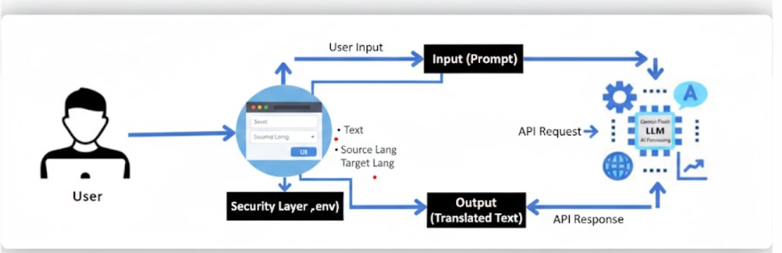

2. Project Objectives
The primary objectives of this project are:
- Develop a real-time translation system
- Integrate Google Gemini API for AI-powered processing
- Ensure context-aware and tone-preserving translations
- Build an intuitive and interactive UI using Streamlit
- Maintain secure API key management

3. System Architecture Overview
The application follows a simple yet effective architecture:
User Input → Streamlit UI → Gemini API → AI Processing → Translated Output
Components:
- Frontend: Streamlit-based web interface
- Backend Logic: Python script
- AI Engine: Gemini Flash Model
- Security Layer: Environment variables (.env)

4. Setting Up Google Gemini API
To enable AI-powered translation, a GOOGLE_API_KEY is required.
Steps Followed:
- Visit Google AI Studio
Accessed: https://aistudio.google.com
- Authentication
Logged in using a Google Account.
- Create API Key
  - Clicked “Get API Key” from the left sidebar
  - Selected “Create API key in new project”
- Secure Storage
Stored the key inside a .env file:
GOOGLE_API_KEY=your_secret_key_here
This ensures API credentials are not exposed in the source code.

5. Code Explanation (Step-by-Step)
Step 1: Library Imports & Configuration
- streamlit → Builds the web interface
- google.generativeai → Connects to Gemini model
- dotenv → Loads environment variables securely
- os → Fetches system variables
st.set_page_config(page_title="TransLingua Translator", page_icon="🌍")
This sets the browser tab title and icon.

Step 2: Authentication
load_.env()
genai.configure(api_key=os.getenv("GOOGLE_API_KEY"))
- Reads the .env file
- Configures Gemini API securely

Step 3: Model Initialization
model = genai.GenerativeModel("models/gemini-flash-latest")
The Gemini Flash model is optimized for:
- High speed
- Context-aware responses
- Natural language tasks

Step 4: Translation Logic
def translate_text(text, source_language, target_language):
prompt = f"Translate the following text from {source_language} to {target_language}: {text}"
response = model.generate_content(prompt)
return response.text
How it works:
- A structured prompt is created
- Gemini processes the instruction
- The translated text is returned
- The UI displays the result

Step 5: User Interface (UI)
The UI is designed using Streamlit components:
- Text Area → st.text_area()
- Language Dropdowns → st.selectbox()
- Translate Button → st.button()
The interface ensures ease of use and minimal learning curve.

6. Implementation Snippet (Core Logic)
Below is the essential logic used in translang.py:
import streamlit as st
import google.generativeai as genai

def translate_text(text, source_language, target_language):
prompt = f"Translate the following text from {source_language} to {target_language}: {text}"
response = model.generate_content(prompt)
return response.text

7. Key Features
- Multi-language support
- Real-time translation
- Context-aware AI processing
- Secure API key handling
- Lightweight and deployable
- Clean and interactive UI

8. Project Output
Output Screenshot 1: Initial UI
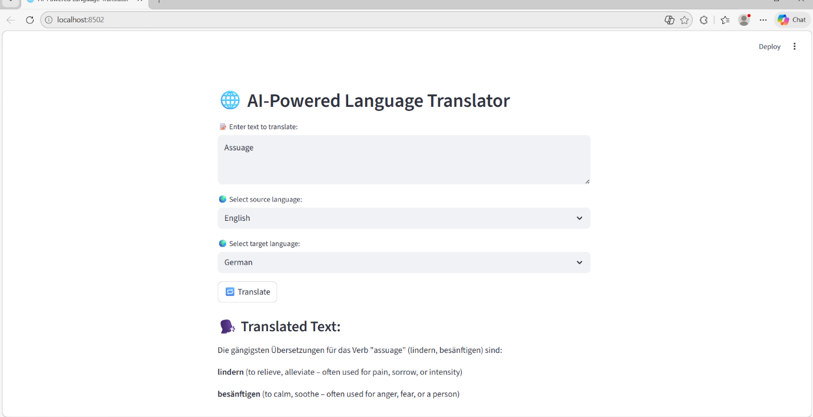
Description:
Displays the dashboard with:
- Language selection dropdowns
- Text input area
- Translate button

Output Screenshot 2: Successful Translation
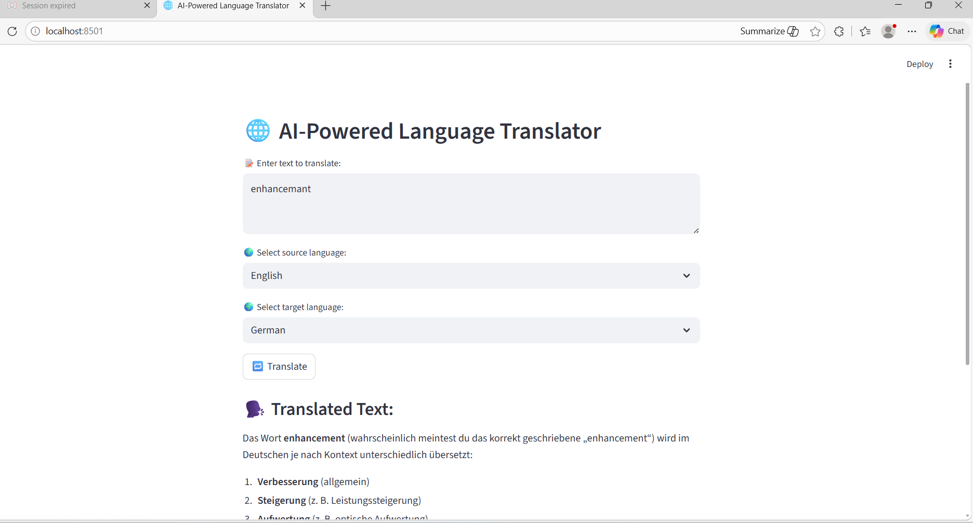
Description:
Shows a successful translation result from English to Spanish, generated using the Gemini model.

9. Advantages Over Traditional Translators
Traditional Translators | TransLingua (GenAI-Based)
Rule-based translation | Context-aware AI
Literal word conversion | Tone & meaning preservation
Limited adaptability | Learns patterns dynamically
Grammar inconsistencies | Natural language fluency

10. Limitations
- Requires internet connection
- Dependent on API quota limits
- May require prompt refinement for highly technical text

11. Conclusion
The TransLingua AI-Powered Translator successfully demonstrates the practical integration of Generative AI with a web-based user interface.
By combining:
- Python for backend logic
- Streamlit for rapid UI development
- Google Gemini Flash for intelligent translation
the project achieves:
✔ High accuracy
✔ Real-time performance
✔ Context-aware results
✔ Clean and scalable architecture
This project highlights the growing role of Generative AI in solving real-world communication challenges and serves as a strong foundation for building enterprise-grade multilingual solutions.

